ASR 6191

Update date: [2016.06.30]

# e-Tracker Changes

1. Tracking list: - added Tare weight , cargo weight and gross weight

WMS will auto update the below container information after loading completed to e-tracker:

Total No of Packages, Tare weight ,Cargo Weight, Gross weight

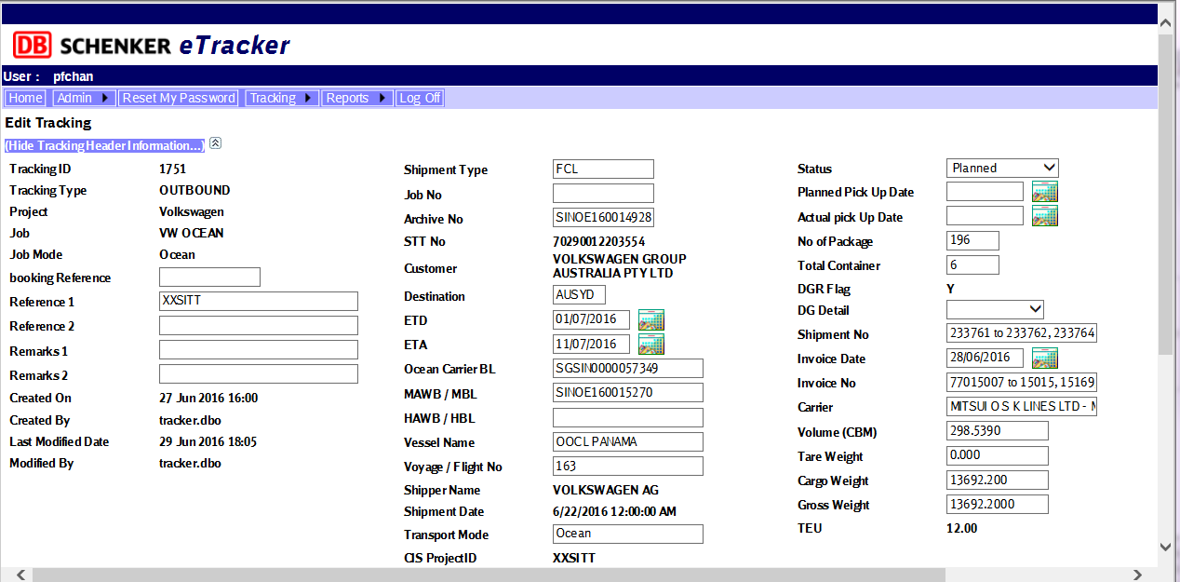

1. Container detail :

WMS will auto update the below container information after loading completed to e-tracker:

No of Packages, Tare weight , Cargo Weight, Gross weight

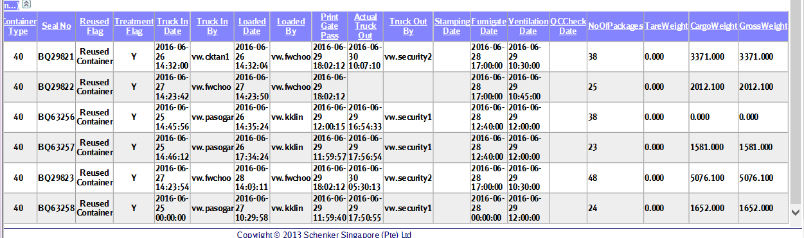

1. Outbound Shipment - Container Detail Report

Description: report will retrieve the container detail information:

Container volume, container tare weight, container cargo weight and gross weight

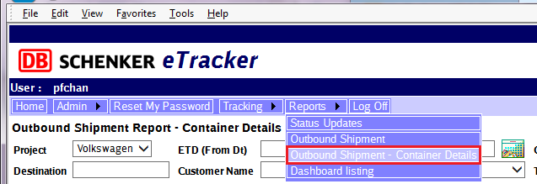

Retrieve by Tracking ID

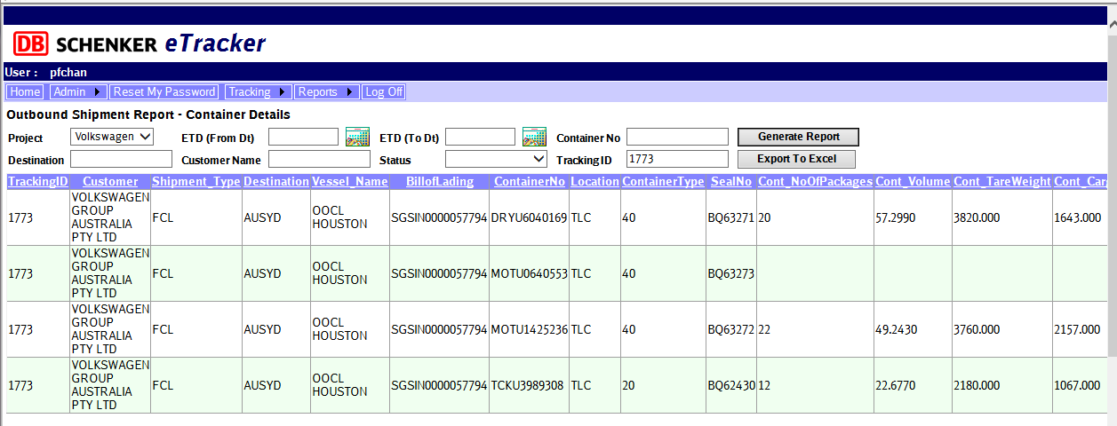

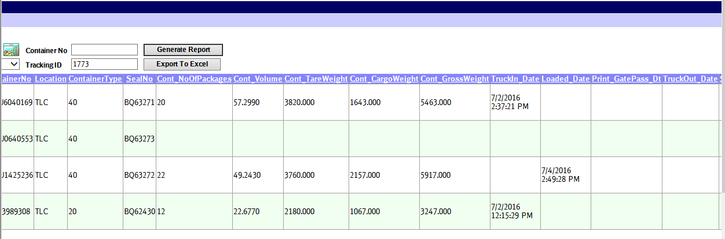

Container volume,

container tare weight, cargo weight and gross weight

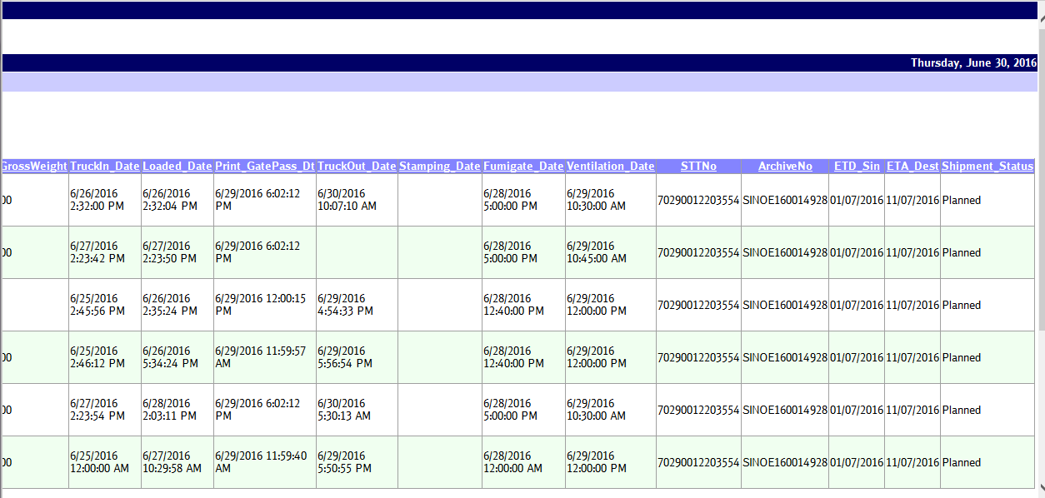

1. Outbound Shipment Report – add total tare weight and cargo weight

